Control Panel of robot Mobile App  
  
This App created by MIA App Inventor  
1. App Inventor Interface :  
  
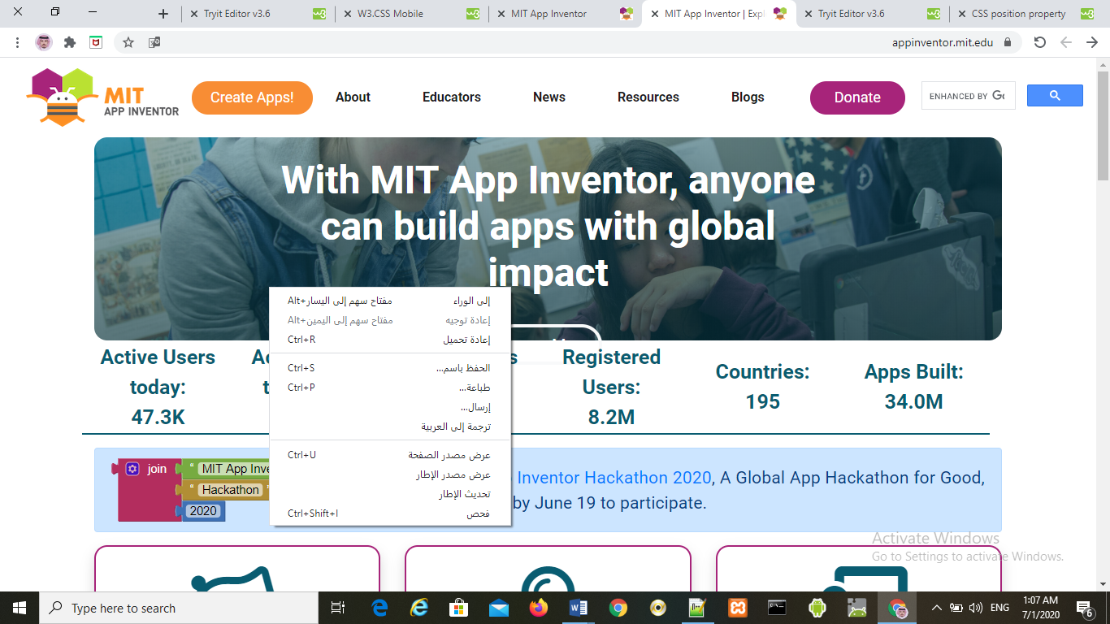2. Sign up with Google Accuont .

3. We have 2 Methods to create app :  
3.1 by Design said .  
3.2 by Block said .

3.1 Design said   
1.by Drag WebViewer   
2.change App name  
3.upload Robot Icon in background  
  
  
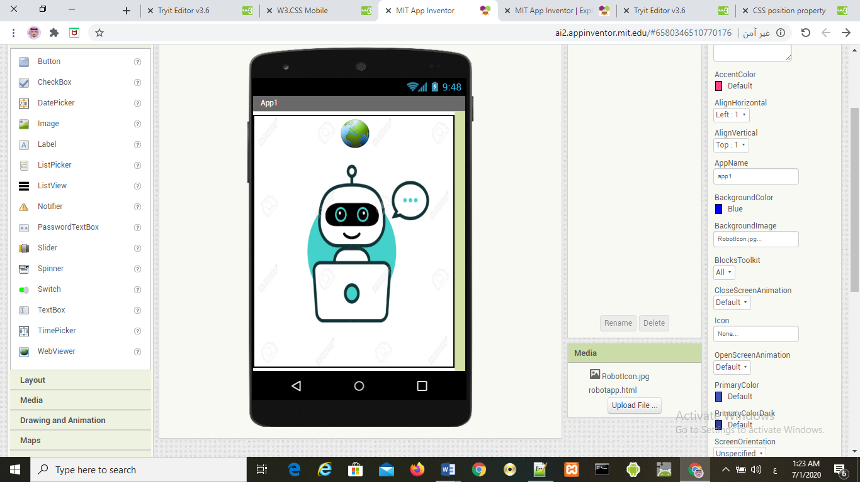

3.2 by Block said :  
1.Drag Screen initial block :  
  
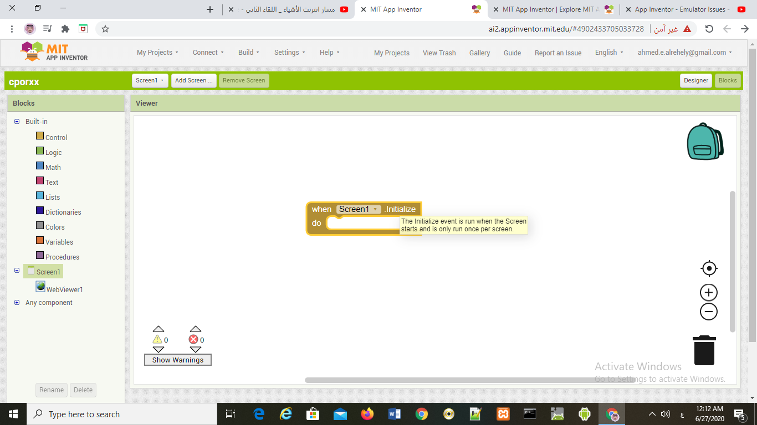

2.Drag Go To URL block :  
  
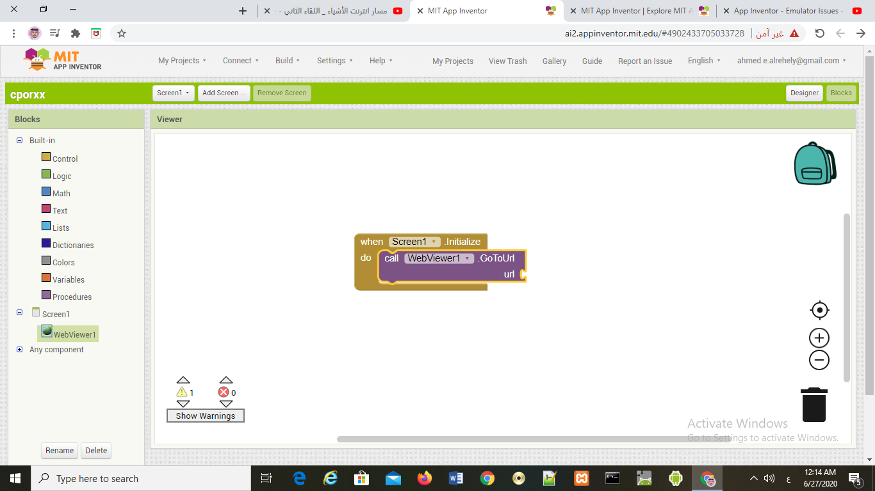  
  
3. Drag Text block and paste the last HTML code

(file:///android_asset/robotapp.html)  
(<http://ai2.appinventor.mit.edu/#6580346510770176>)  
  
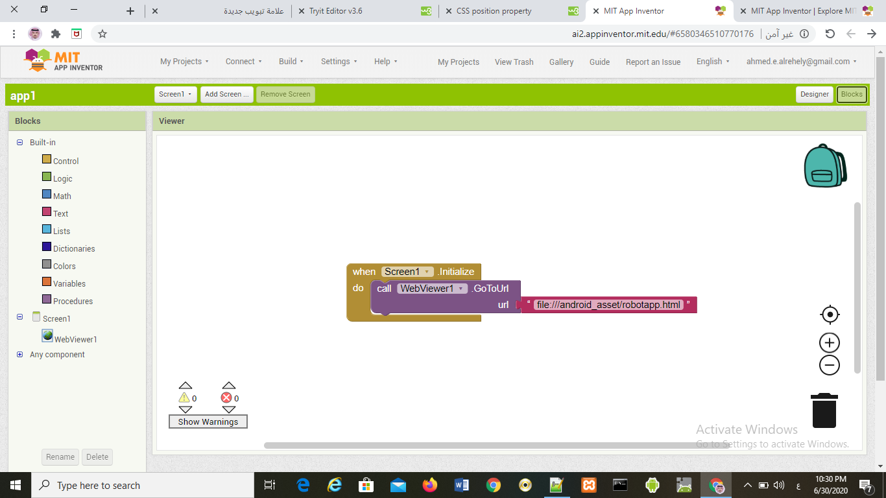

3.Build by (provide QR code for .apk) or use Emulator :  
  
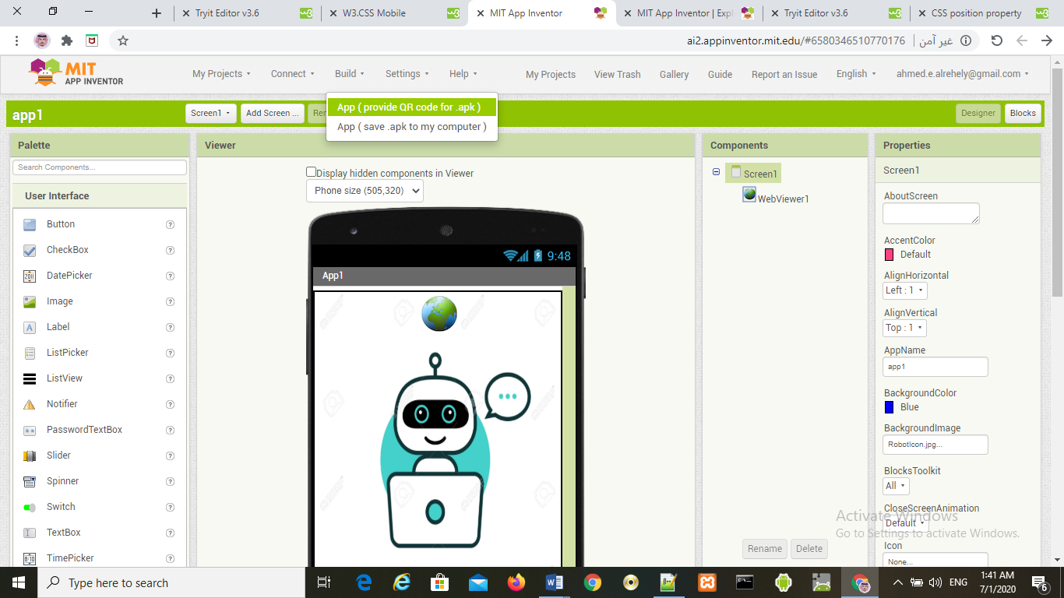

Or use Connect With Emulator :  
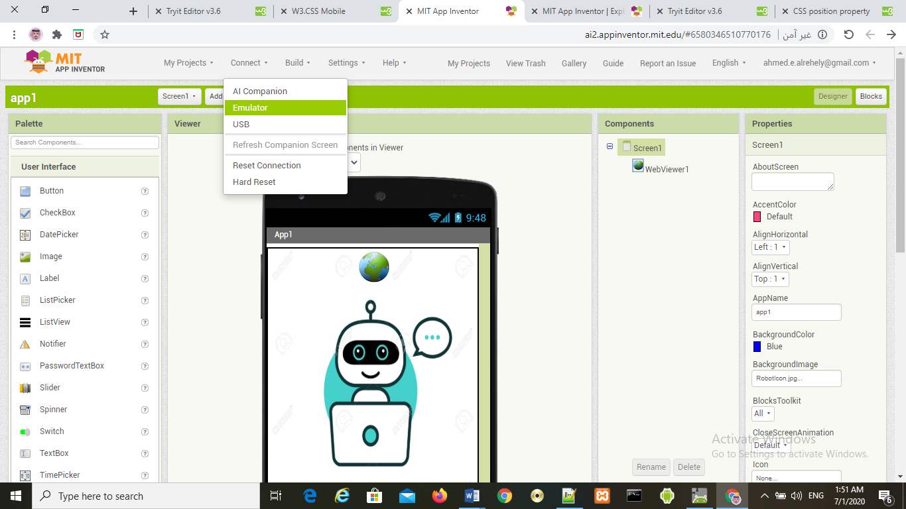  
  
4. Final Output :  
